DAY 3 – MANUAL TEST CASE MANAGEMENT (XRAY)
1. Test Creation
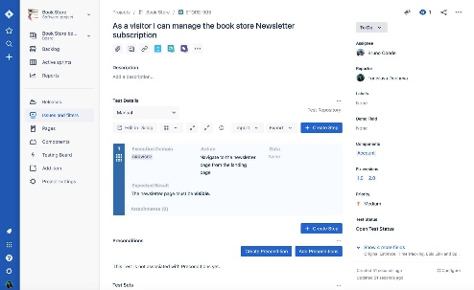

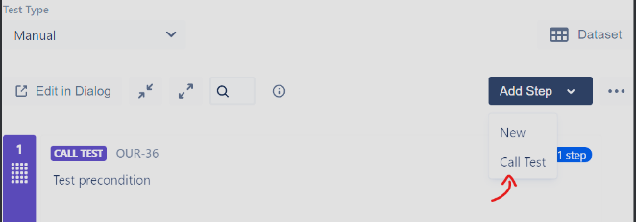
1.1 Creating a Test Issue
In Xray Test Management, a Test issue represents a manual test case.
Steps to Create a Test:
- Click Create Issue
- Select Issue Type → Test
- Enter:
  - Summary (Test case title)
  - Description (what is being tested)
  - Test Type → Manual
- Save the Test
📌 Example (Real Project):
Summary: Verify user login with valid credentials

1.2 Writing Test Description
A good test description explains:
- Purpose of the test
- Feature being validated
- Expected behavior
📌 Best Practice:
- Clear
- Simple
- Business-readable
- No technical jargon

1.3 Using Preconditions
Preconditions define what must be true before executing a test.
Examples:
- User must be registered
- Application server is running
- User is logged out
📌 How to Use Preconditions
- Create a Precondition issue
- Describe the condition
- Link it to multiple Tests
✅ Benefit: Avoids repeating the same setup steps in every test.

2. Test Design

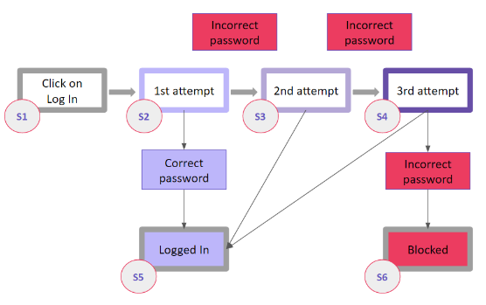

2.1 Step-Based Tests
Used when validation requires clear step-by-step actions.
Structure:
Step | Action | Expected Result
1 | Enter username | Username accepted
2 | Enter password | Password accepted
3 | Click Login | User redirected to dashboard
📌 When to Use:
- UI testing
- Functional flows
- Regression testing

2.2 Unstructured Tests
Written as free-text scenarios without steps.
📌 Example:
Verify that the application handles invalid login attempts correctly and displays appropriate error messages.
📌 When to Use:
- Exploratory testing
- High-level validations
- UX testing

2.3 Real-Project Test Selection
Choose test type based on:
- Feature complexity
- Risk level
- Business impact
📌 Example Mapping:
- Login → Step-based
- UI consistency → Unstructured
- Payment flow → Step-based

3. Test Organization
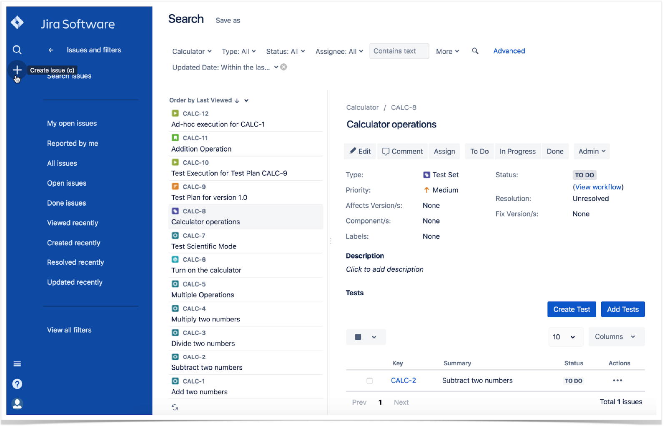
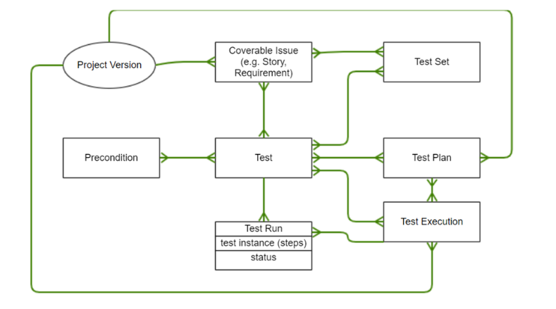

3.1 Test Sets
Test Sets are logical containers for grouping tests.
📌 Why Test Sets?
- Better organization
- Easy execution
- Faster regression cycles

3.2 Smoke Tests
Smoke tests verify basic system stability.
📌 Examples:
- Application launch
- Login
- Dashboard load
📌 Best Practice:
Create a Smoke Test Set executed after every build.

3.3 Regression Test Grouping
Regression tests ensure existing features still work.
📌 Grouping Strategy:
- Core features
- Critical workflows
- Previously failed areas

3.4 Feature-wise Grouping
Organize tests by:
- Login Module
- Payment Module
- Profile Module
📌 Advantage: Easy maintenance and reporting.

4. Linking Strategy & Traceability
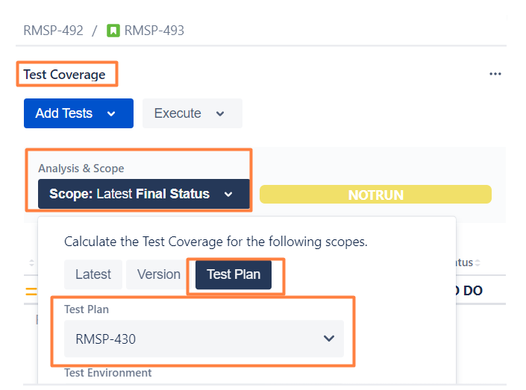
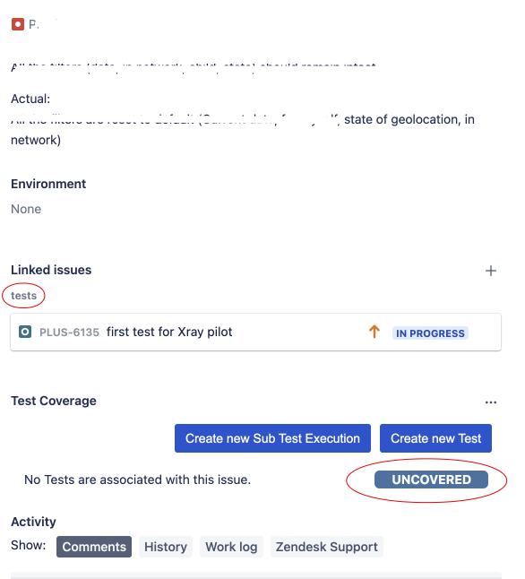
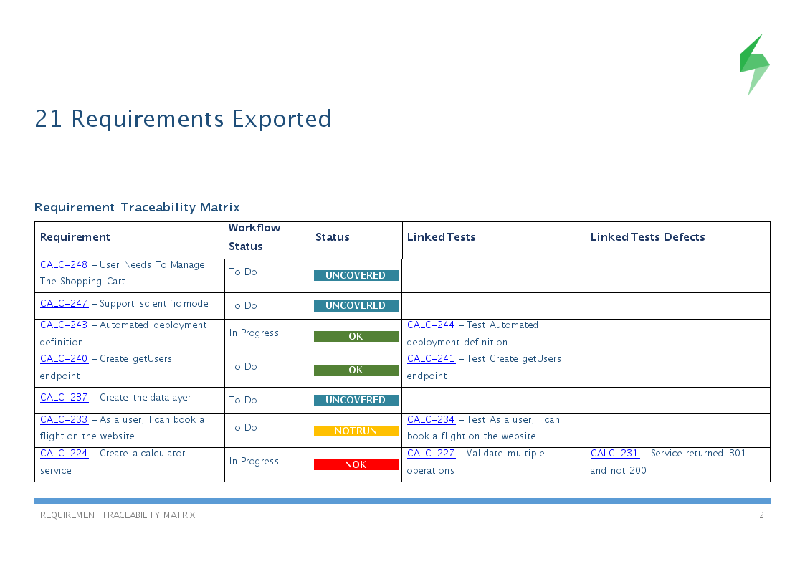

4.1 Linking Tests to Stories
Each Test should be linked to a requirement.
📌 Steps:
- Open Test issue
- Link → Tests
- Select User Story
Enables requirement coverage tracking.

4.2 Linking Tests to Tasks & Bugs
- Tasks: Validate sub-features
- Bugs: Identify failed behavior
Best Practice:
- Bug → linked to failed Test Execution
- Test → linked to Story

4.3 Traceability Visualization
Xray provides:
- Coverage percentage
- Untested requirements
- Failed test impact
Helps stakeholders assess release readiness.

5. Hands-on Lab (Mandatory)
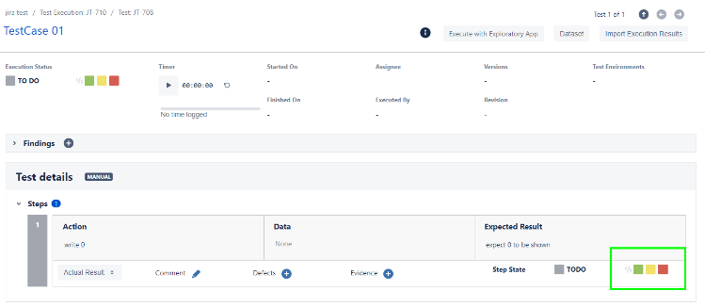
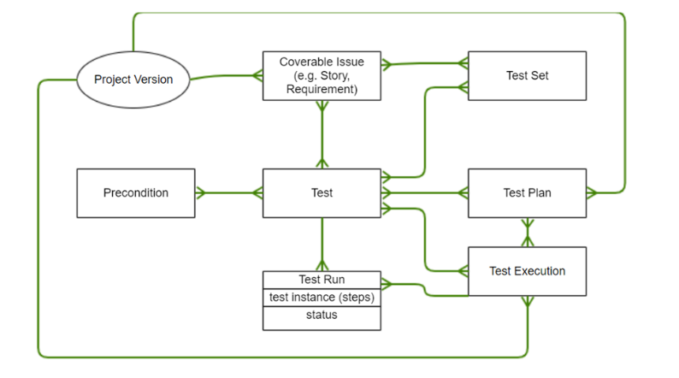
Hands-on Tasks
🔹 Task 1: Write Manual Test Cases
- Create 3 Tests
- Use step-based format
- Add Preconditions

🔹 Task 2: Organize Tests
- Create 2 Test Sets
  - Smoke Tests
  - Regression Tests
- Add created Tests

🔹 Task 3: Link Tests
- Link Tests to:
  - 1 User Story
  - 1 Bug (if applicable)

🔹 Task 4: Validate Traceability
- Open Story
- Check Coverage Panel
- Verify linked Tests visibility

6. Summary
Day 3 focused on manual test case creation, design, organization, and traceability using Xray.
By practicing real-project scenarios, students gain the ability to:
- Write high-quality manual test cases
- Organize tests efficiently
- Maintain end-to-end requirement traceability
- Prepare test assets for execution and reporting

